TUMC WEEKLY NEWS – November 14, 2021
3503 Lincoln Highway, Thorndale, PA 19372
610-384-2433 www.thorndaleumc.org

INSPIRED WORSHIP
Out of our devotion to God we gather for worship, offering weekly services and other opportunities to praise God through song, prayer, giving and gratitude.

This week’s scripture: Mark 13:1-8 “Enough to Hope”

Livestreaming of our 9:15 am
Worship Service:
We are so grateful that anyone can join us for worship from home (or anywhere) in real time or watch at your personal convenience! Just log-on to our YouTube channel (link is below the graphic.) Click the subscribe button while you are there and feel free to leave comments in the comment section too.
https://www.youtube.com/channel/UCCwKffzSZ9By5sasoPFftNA

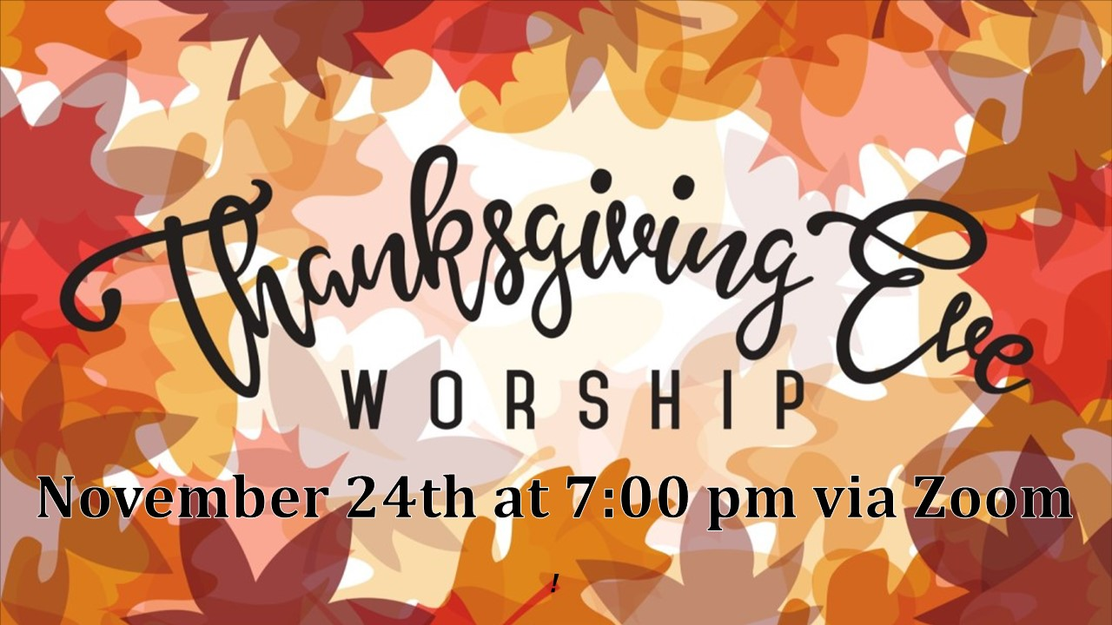

OUR SANCTUARY IS OPEN FOR PRAYER - The sanctuary is open for a time of prayer beginning at 8:45 AM, prior to our 9:15 AM Sunday worship. Come. Sit and pray. Our Sanctuary is also always open during our office hours for you to come and pray and meditate.

In order to keep everyone safe, we have returned to wearing masks indoors no matter your vaccination status. We will continue to take Worship attendance in order to provide contact tracing should it be required. Thank you for your understanding, continued flexibility, and adherence to these protocols. Masks will be available at the door if you forget to bring one.

Our preschool is currently seeking to hire a part-time teacher’s assistant for our Pre-K class. We are looking for someone with prior preschool experience and prefer the individual to have prior experience as a classroom assistant.

For a more detailed job description or to apply contact Laura Venezia at tlcdirector@thorndaleumc.org. Days are M-W-F from 8:30 AM until 12:30 PM. Preschool tuition discount is available.

INTENTIONAL SPIRITUAL DEVELOPMENT.
Jesus commands us to make disciples, by teaching and encouraging all to grow in their faith.

There are just a few “large-print” November/December Upper Room devotionals remaining. They are on the table at the front door for easy pick-up.

FAITHFUL STEWARDSHIP
God is the giver of every gift. Therefore, we will grow in our generosity to be active in our mission and ministries through our prayers, presence, gifts, service, and witness.
THANK YOU for making a difference with your AMAZON smile shopping. It makes a difference with no additional cost to you! We recently received $10.38 donation from the AmazonSmile Foundation. Know, that YOU ARE making a difference when you shop at smile.amazon.com/ch/23-7408418

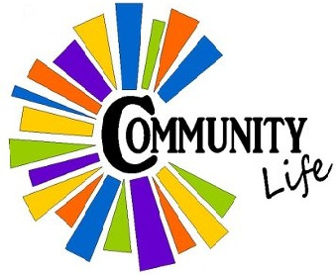
HEALTHY COMMUNITY LIFE
Providing opportunities to build and strengthen relationships within our faith community through communication, collaboration, and accountability.

Upcoming November Birthdays:
11/18 – Deb Aberts 11/21 – Autumn Hart
11/21 - Christine Moore 11/24 – Jeff Clark
11/26 – Kim Kramer 11/27 – Ken Kramer
11/30 – Carol Barnes 11/30 – Ruth Battin

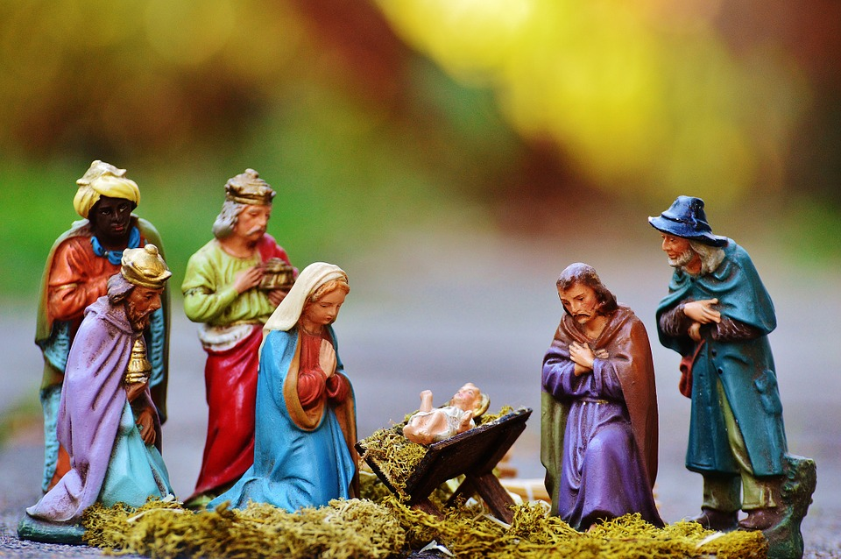
Christmas Decorating (ALREADY?)

It is hard to believe, but Christmas decorating is just a few weeks away since Advent begins on November 28. This year the big day for decorating is November 27 at 9 AM to finish, and the more hands, the earlier finish will be. If you are only available for part of the morning, please come for whatever amount of time you can give.

The Advent theme is “The Inn,” and in keeping with the theme, there will be a display of nativity scenes, with the emphasis on the unusual, especially those from other countries. There will be a display throughout Advent; but if you can only spare your set for one Sunday, that is fine also. You could bring it on Sunday morning and take it home with you after worship.

One other thing is needed for Advent decorating, and that is wooden crates. If you have a wooden crate or more than one that you could lend for the season, it would be greatly appreciated. The project requires four crates, and there is already one at the church.

There will be some outdoor decorating to be done as well so that the community is able to participate in our celebration even before they consider coming through the doors or checking out the services online. Decorating is not merely making the church look festive, it is a reflection of the story of Jesus’ birth and his welcome into the world.

The 2021 Flower Chart to sponsor altar flowers has been posted

on the bulletin board outside the church office. Feel free to sign-up when
you are here or call the church office to sign-up for your special day.
Thank you to those who have sponsored flowers. The following dates are open for sponsorship: Nov. 28, December 5 and 19.

CHRISTMAS POINTSETTIAS
Believe it or not, it’s time to begin to think about ordering poinsettias for Christmas. This year the greenhouse has red, white, pink, burgundy or pink marble poinsettias. Poinsettias come in 6” pots and are $8 each. Please contact the church office at 610-384-2433 to place your order. Deadline is Wednesday, December 8 as nursery needs 10 days of advance order time.

You have the option to have your flowers placed in memory of a loved one, in honor of someone or to provide a donation to our discretionary fund which helps supports the needs of our community. Flowers may be taken following our Christmas Eve services or picked up the following week from the church office.
Shut-ins
Listed below are our shut-ins and their mailing addresses if you would like to send them a card.
Onzelle Barber Hickory House, 3120 Horseshoe Pike, Honey Brook, PA 19344
Shirley Hammons Harrison House, Room 224, 300 Strode Avenue, Coatesville, PA 19320
Gretna Crossan Newport Meadows, 41 Newport Avenue, Birch Unit, Rm. 206,
Christiana, PA 17509
ACTIVE OUTREACH
We are ambassadors for Christ, called to
share Him with our community and beyond.

MARK YOUR CALENDARS
HIBERNIA UMC
November 20, 2021
9:00 AM - 3:00 PM
Craft Vendors and Silent Auction. Lunch and soup available for purchase.

Our very own Daryl Orr will be there. Stop by his table
Veteran’s Day tribute with live veteran music
performances.

Saturday, November 20, 2021
4:00 PM – 7:00 PM
Worship Center

Sponsored by Stages Arts Initiative

Caln Elementary School
“Truly I tell you, whatever you did for one of the least of these brothers and sisters of mine, you did for me.” Matthew 25:40 NIV

For our November donation, we will be helping the teachers provide Thanksgiving meals for several Caln families by collecting monetary donations toward the purchase of Giant gift cards which will be used to purchase turkeys for the families. Any donation amount is appreciated, as the money will be pooled to purchase the gift cards. Donations may be mailed to the church or dropped off in the office during office hours. For your convenience, there are green donation envelopes, labeled Caln Elementary-Thanksgiving Gift Cards, located in a basket on a table at the front door or in the rack at the Welcome Center. Checks should be made payable to TUMC. Please write Caln donation on the memo line. We have also added a giving option on our giving link on the website for this month’s Caln Ministry. Just go to the website at thorndaleumc.org and click on the “giving” link.

So that the gift cards can be delivered to the school and the turkeys purchased in time for Thanksgiving, this will be a shortened collection period. Monetary donations will be due no later than Sunday, November 21.

Thank you for your continued support and prayers for this ministry.
Holly Orr, Caln School Coordinator

Collection Drive for Afghan Refugees
We continue to be an area collection site for the Afghan Refugee drive. There is a great need for strollers, baby items and school supplies. At this time, they have asked us to pause on the collection of toys, and especially stuffed animals. With winter approaching, fall/winter coats and other fall and winter items are also in need. Items may be dropped off during office hours or on Sunday morning.
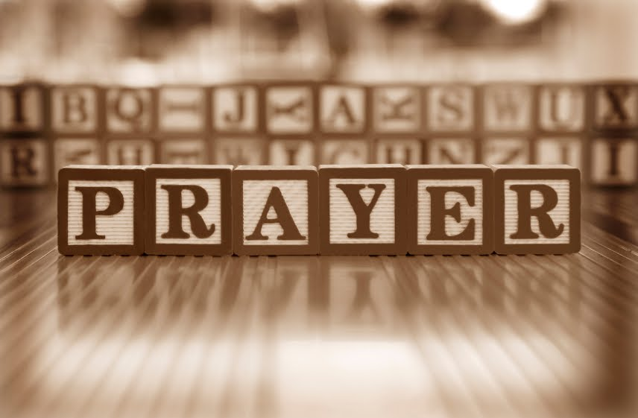
“Every morning tell him, “Thank you for your kindness,” and every evening rejoice in all his faithfulness. Psalm 92:2 TLB

Where have you experienced God’s presence in your life this week?
- So many friends helping me through some difficult times.
- Playing with grandchildren.
- Strength to finish updating deck.
Praise and Thanksgiving:
That our bathroom remodel is done Fun time with niece and nephew.
Diana went back to work. For Bill’s know how

Traveling Mercies: Stan and Karen Reaves Dave & Sue Davis from WI.
Mike J.

Treatment and Tests: Nancy McDowell-radiation Diane Huggler-chemo
For MRI to find problem. Faith S.

Surgery/Procedures: Tim F. – knee replacement Lois M-surgery 11/12
Lois H – knee surgery-Nov 18 Matt Scott-Nov 18

Condolences: For all that have lost loved ones this year. Kennedy and Defonzo family.

Hospital: Mark A-heart ablation 11/9

Pray for our Staff: Pastor Shauna

Pray for our Ministry Team: Prayer Team

Pray for our students from TLC: Aarav. Ayann. Dylan. Ensley.
Pray for our Outreach Ministries: CYWA

Other: Staffing need in TLC Those suffering loss. Aubree
For those kidnapped in Haiti Carl & Ivan Purcell
To be able to grow our family. Afghan refugees to adjust to new lives here
Young people: Mike & Chris Kramer, Sarah, and Katy Hanks
Peace and comfort-Marjorie G. and family
Peace and comfort for the Regener family (Debbie, John and Jacqui)

Healing
Larry B-eye problem after cataract surgery Doris Kramer
Robert T-blood clot Clara Parsons-fall Aunt Anne-hip fracture
Jodi A. Carl Purcell Clyde Thomas
Nancy J.-heart surgery Chuck M (Holly’s cousin) Meg H.
Lee & Shirley Carroll Phillip Byers Helen Pennell
Jean Brown-broken hip Bob-knee replacement Bill Lyman
Lois M.

